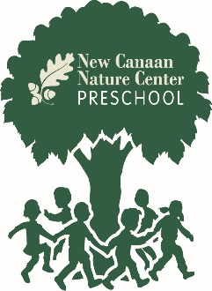
2021– 2022 Admissions Process
In School Families
(Current students, siblings, alumni & MM&N students)
November 20, 2020
Admissions application and $100 non-refundable application fee are due, holding a spot for your child.

January 15, 2021
Contracts and $500 non-refundable tuition deposit are due.

March 1, 2021
Payment installment plan begins.
August 13, 2021
Health and Emergency Forms are due. These forms will be mailed out over the summer.

New Students

January 8, 2021
Admissions application and $100 non-refundable application fee are due.

January 11 – January 29, 2021
Families will be notified no later than February 1st regarding the acceptance of their child at NCNCPS.

February 12, 2021
Contracts and $500 non-refundable tuition deposit are due.

March 1, 2021
Payment installment plan begins.
August 13, 2021
Health and Emergency Forms are due. These forms will be mailed out over the summer.

